**Exercise 1: Implementing the Singleton Pattern**

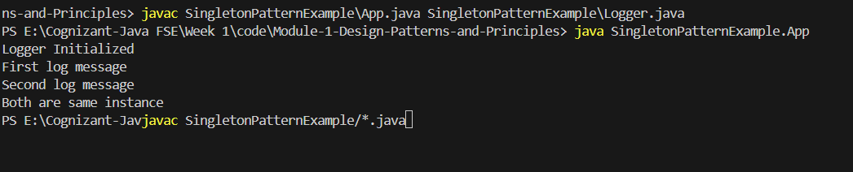

Exercise 2: Implementing the Factory Method Pattern